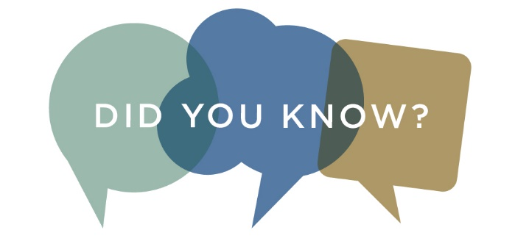

Baltimore County Public Library offers free online tutoring from a real-live, human person, every afternoon and evening.

Brainfuse
Get expert help from tutors at Brainfuse. Have your library card number and password ready.
- Chat live from 2 p.m. to midnight, seven days a week. Spanish-speaking tutors are available
- Send a Question and get an answer within 24 hours
- Use SkillSurfer to practice long division, improve reading comprehension and learn other key skills
- Submit a writing sample to the Writing Lab and get feedback on structure, grammar, style and content to help you better organize and present your thoughts and information

Research Databases
Use our online databases for research and school assignments. Many contain full-text articles from magazines, journals, current and historic newspapers, encyclopedias and more. A valid library card is required.

